1. Create a simple cloud software application and provide it as a service using any Cloud Service Provider to demonstrate Software as a Service (SaaS).

STEP1: GOTO ZOHO.COM

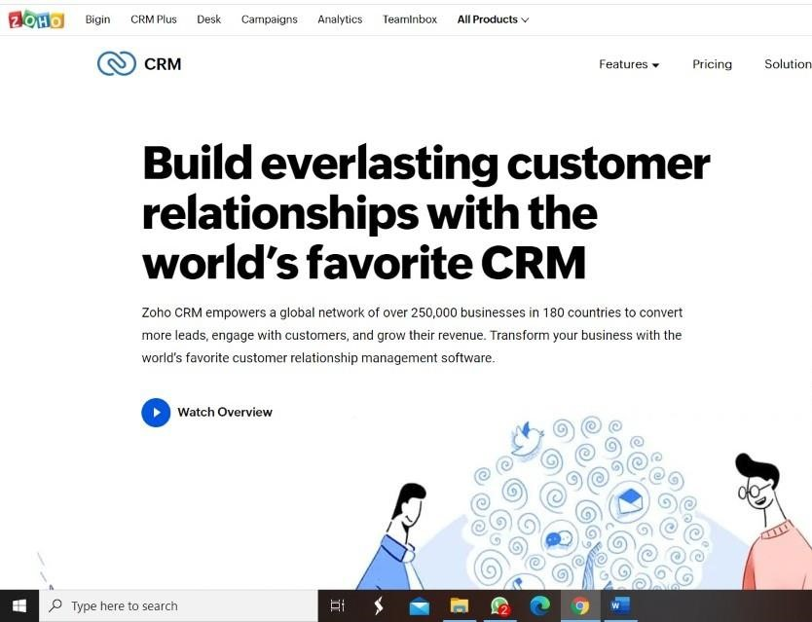

STEP 2: LOGIN TO THE ZOHO.COM



STEP 3: SELECT ONE APPLICATION

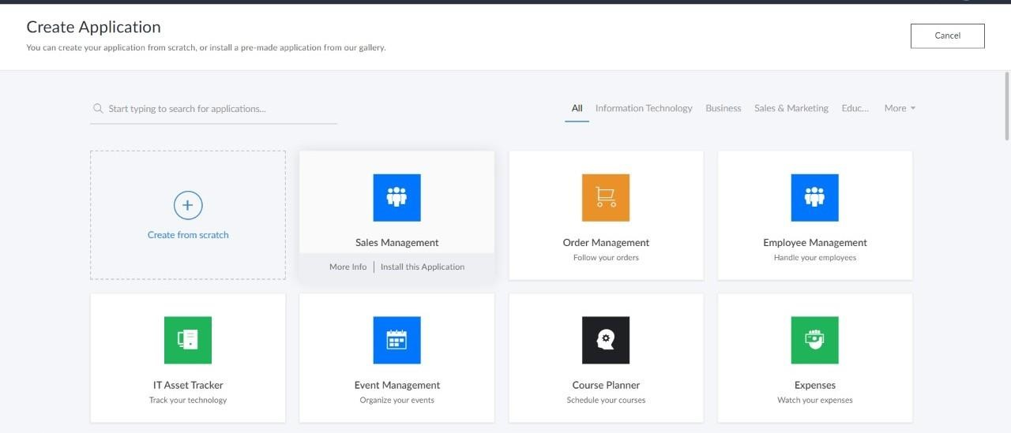

STEP 4: ENTER APPLICATION NAME

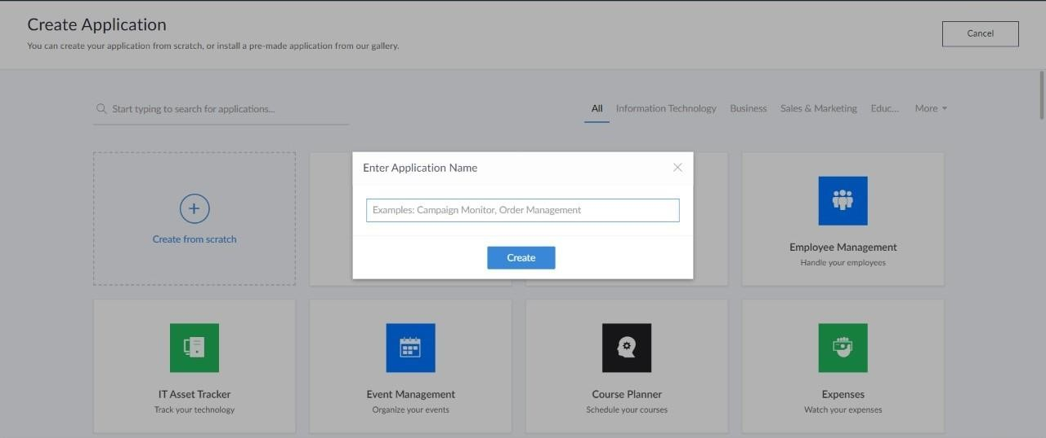

STEP 5: CREATED NEW APPLICATION

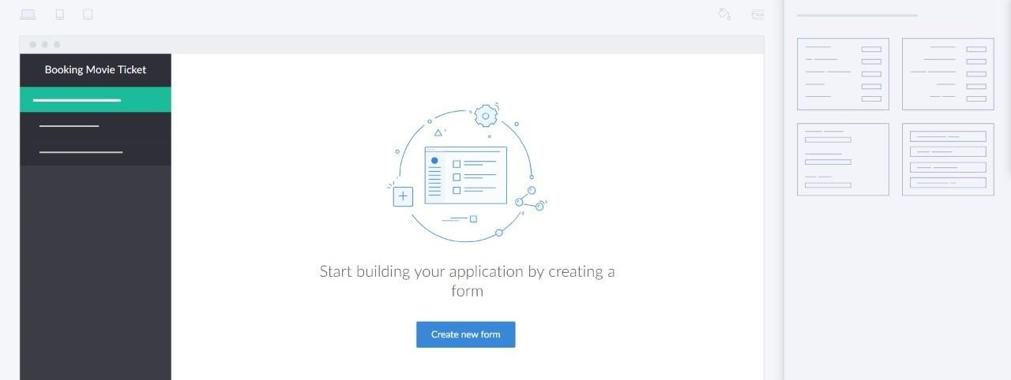

STEP 6: SELECT ONE FORM

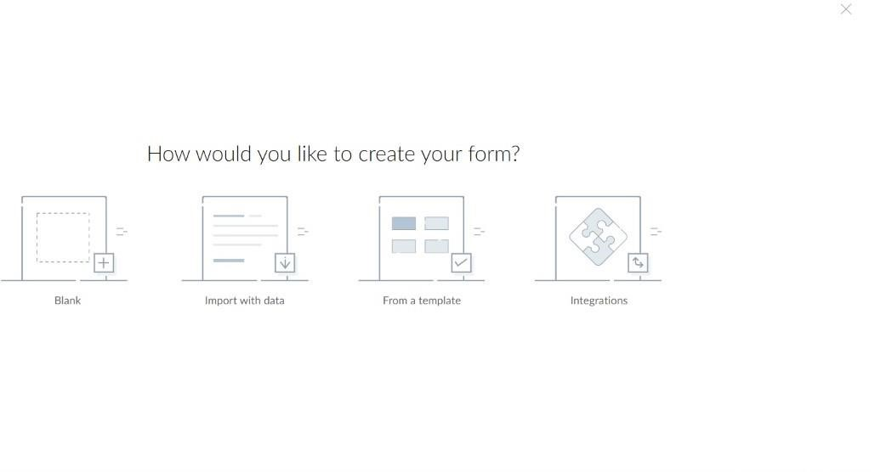

STEP 7: THE SOFTWARE HASE BEEN CREATED.

N